**\*Update Command\***

**1. Add email column in emp table.**

alter table emp add column email varchar(20);

Query OK, 0 rows affected (0.09 sec)

Records: 0 Duplicates: 0 Warnings: 0

**Output:**

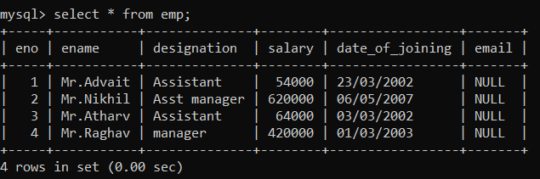

**2. Update all email of employee present in given table.**

mysql> update emp set email='mradvait@gmail.com' where eno=1;

Query OK, 1 row affected (0.02 sec)

Rows matched: 1 Changed: 1 Warnings: 0

mysql> update emp set email='mrnikhil@gmail.com' where eno=2;

Query OK, 1 row affected (0.01 sec)

Rows matched: 1 Changed: 1 Warnings: 0

mysql> update emp set email='atharv@gmail.com' where eno=3;

Query OK, 1 row affected (0.03 sec)

Rows matched: 1 Changed: 1 Warnings: 0

mysql> update emp set email='raghav@gmail.com' where eno=4;

Query OK, 1 row affected (0.02 sec)

Rows matched: 1 Changed: 1 Warnings: 0

**Output:**

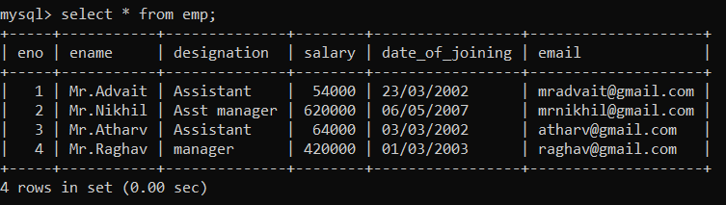

**3. Increment 5% salary of all employee.**

mysql> update emp set salary=salary+(salary*0.05);

Query OK, 4 rows affected (0.02 sec)

Rows matched: 4 Changed: 4 Warnings: 0

**Output:**

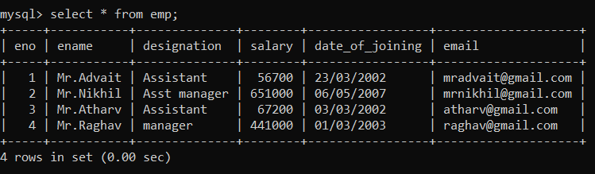

**4. Update the post of Mr. Raghav to senior manager.**

mysql> update emp

-> set designation='Sr.manager'

-> where ename='Mr.Raghav';

Query OK, 1 row affected (0.01 sec)

Rows matched: 1 Changed: 1 Warnings: 0

**Output:**

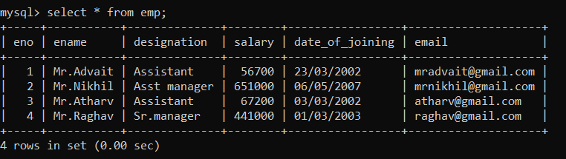

**5. Update the employee position with ‘Sr. Assistant Manager’ whose previous post is ‘Assistant’.**

mysql> update emp

-> set designation='Sr. Assistant Manager'

-> where designation='Assistant';

Query OK, 2 rows affected (0.02 sec)

Rows matched: 2 Changed: 2 Warnings: 0

**Output:**

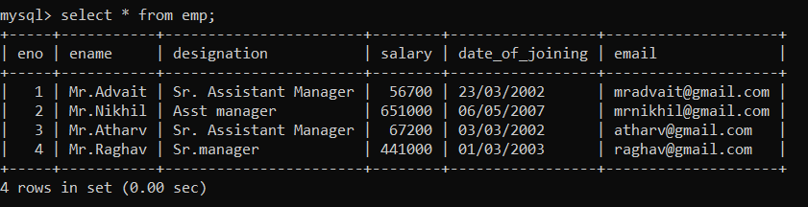

**6. Add city column to emp table.**

mysql> alter table emp add column city varchar(30);

Query OK, 0 rows affected (0.02 sec)

Records: 0 Duplicates: 0 Warnings: 0

**Output:**

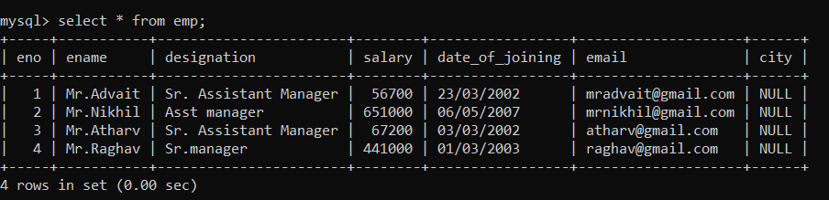

**7. Update city column.**

mysql> update emp set city='Pune' where eno=1;

Query OK, 1 row affected (0.01 sec)

Rows matched: 1 Changed: 1 Warnings: 0

mysql> update emp set city='Kolhapur' where eno=2;

Query OK, 1 row affected (0.02 sec)

Rows matched: 1 Changed: 1 Warnings: 0

mysql> update emp set city='Mumbai' where eno=3;

Query OK, 1 row affected (0.01 sec)

Rows matched: 1 Changed: 1 Warnings: 0

mysql> update emp set city='Ratnagiri' where eno=4;

Query OK, 1 row affected (0.02 sec)

Rows matched: 1 Changed: 1 Warnings: 0

**Output:**

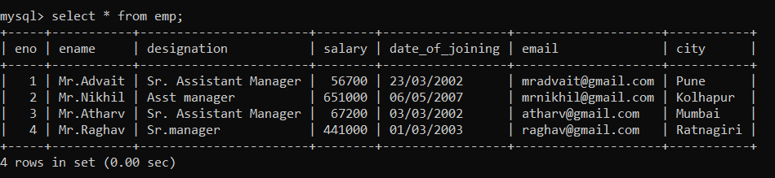

**8. Update record of Mr.Advait because he is shifted from Pune to Mumbai.**

mysql> update emp

-> set city='Mumbai'

-> where ename='Mr.Advait';

Query OK, 1 row affected (0.02 sec)

Rows matched: 1 Changed: 1 Warnings: 0

**Output:**

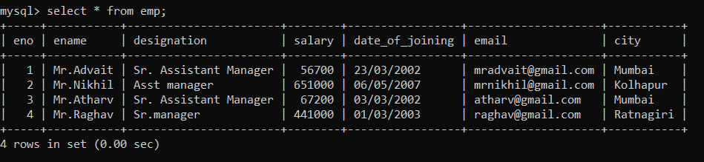

**9. Decrement 5% salary of employee having designation is Ceo and live in Pune.**

mysql> insert into emp(eno,ename,designation,salary,date_of_joining,email,city)

-> values(5,'Mr.Sanket','Ceo',850000,'10/01/2002','sanket@gmail.com','Pune');

Query OK, 1 row affected (0.01 sec)

mysql> update emp

-> set salary=salary-(salary*0.05)

-> where designation='Ceo' and city='Pune';

Query OK, 1 row affected (0.02 sec)

Rows matched: 1 Changed: 1 Warnings: 0

**Output:**

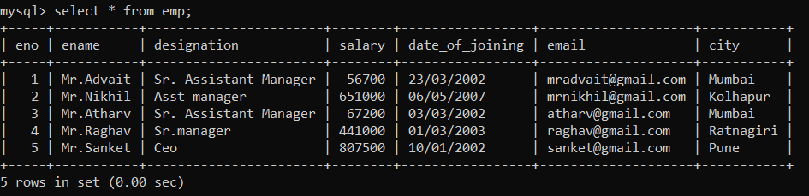

**10. Add column phone_No into emp table with data type int.**

mysql> alter table emp add column phone_No int(10);

Query OK, 0 rows affected, 1 warning (0.06 sec)

Records: 0 Duplicates: 0 Warnings: 1

**Output:**

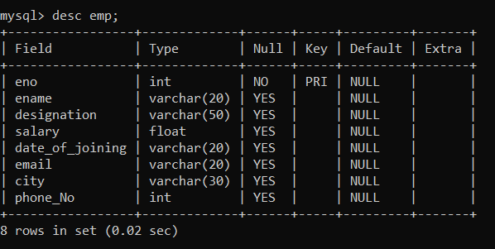

**11. Update date_of_joining of employee to ‘15/06/2019’ whose name is ‘Mr.Roy’ and belongs to Mumbai city.**

mysql> insert into emp(eno,ename,designation,salary,date_of_joining,email,city)

-> values(6,'Mr.Roy','Vice President',700000,'18/01/2007','roy24@gmail.com','Mumbai');

Query OK, 1 row affected (0.01 sec)

mysql> update emp

-> set date_of_joining='15/06/2019'

-> where ename='Mr.Roy' and city='Mumbai';

Query OK, 1 row affected (0.03 sec)

Rows matched: 1 Changed: 1 Warnings: 0

**Output:**

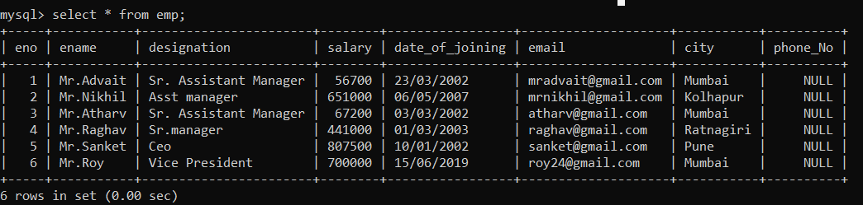

**12. Change date_of_joining of employee ‘olddate’ to ‘newdate’.**

mysql> update emp

-> set date_of_joining='12/04/2002'

-> where eno=1;

Query OK, 1 row affected (0.04 sec)

Rows matched: 1 Changed: 1 Warnings: 0

mysql> update emp

-> set date_of_joining='08/06/2007'

-> where eno=2;

Query OK, 1 row affected (0.04 sec)

Rows matched: 1 Changed: 1 Warnings: 0

mysql> update emp

-> set date_of_joining='03/04/2002'

-> where eno=3;

Query OK, 1 row affected (0.03 sec)

Rows matched: 1 Changed: 1 Warnings: 0

mysql> update emp

-> set date_of_joining='15/03/2003'

-> where eno=4;

Query OK, 1 row affected (0.02 sec)

Rows matched: 1 Changed: 1 Warnings: 0

mysql> update emp

-> set date_of_joining='12/02/2002'

-> where eno=5;

Query OK, 1 row affected (0.02 sec)

Rows matched: 1 Changed: 1 Warnings: 0

**Output:**

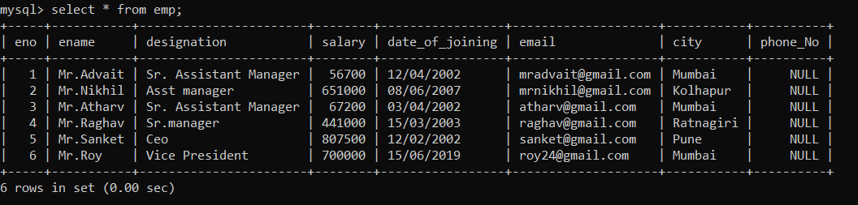

**\*Select Clause\***

**1. Display all details of employee whose name is Mr.Roy.**

mysql> select * from emp

-> where ename='Mr.Roy';

**Output:**

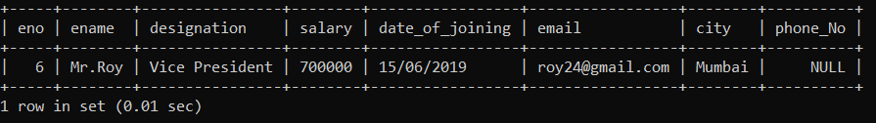

**2. Display salary and designation of employee whose eno is 4.**

mysql> select designation, salary from emp

-> where eno='4';

**Output:**

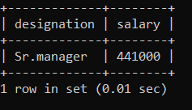

**3. Display the details of employee whose designation is Ceo.**

mysql> select * from emp

-> where designation='Ceo';

**Output:**

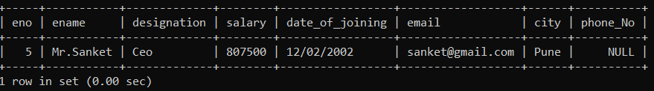

**4. Display date_of_joining of employee where eno=1.**

mysql> select date_of_joining from emp

-> where eno='1';

**Output:**

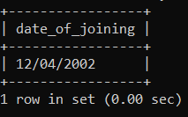

**5. Logical Operator.**

**a) Display the details of employee whose salary is >= 50000.**

mysql> select * from emp

-> where salary>50000;

**Output:**

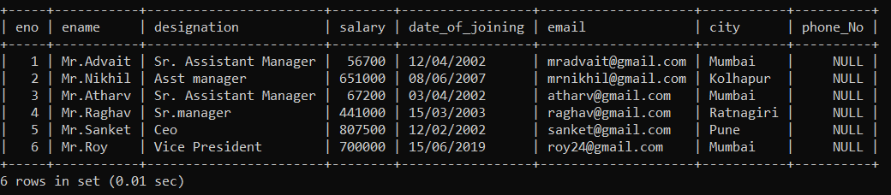

**b) Display salary, designation of employee whose eno=4.**

SELECT salary,designation FROM `emp` WHERE eno=4;

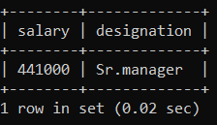

**c) Display eno, ename of employee whose salary > 50000.**

SELECT eno,ename FROM `emp` WHERE salary>50000;

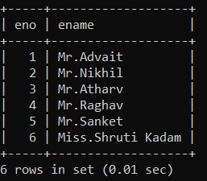

**d) Display details of employee whose salary < 200000.**

mysql> SELECT * FROM `emp` WHERE salary<200000;

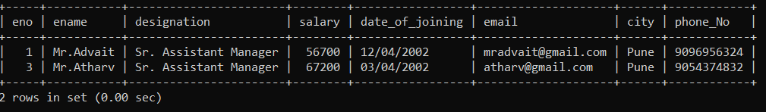

**e) Display details of employee whose salary > 56700.**

SELECT * FROM `emp` WHERE salary>56700;

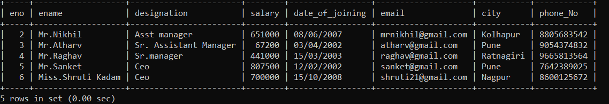

**f) Display details of employee whose salary <> 56700.**

SELECT * FROM `emp` WHERE salary<>56700;

